# How To: Use the ARC Nonword Database

URL: <http://www.cogsci.mq.edu.au/research/resources/nwdb/nwdb.html>

## What is it?

The ARC Nonword Database is a nonword generator containing 358,534 monosyllabic nonwords. Items can be selected based upon a number of possible parameters for use in research.

## How to Search the ARC

1. **Go to** <http://www.cogsci.mq.edu.au/research/resources/nwdb/nwdb.html> Select the types of nonwords that you would like to use in your study using the parameters in the boxes. My suggestion here is to keep it quite simple, as this is not about assessing your psycholinguistic competence, but to ascertain if you can generate a set of nonwords that are plausible in terms of orthographic structure and can effectively match with your word stimuli
2. From the parameters select
   1. Number of words you require
   2. Only orthographically existing onsets
   3. Number of letters (range comparable with that of your real words)

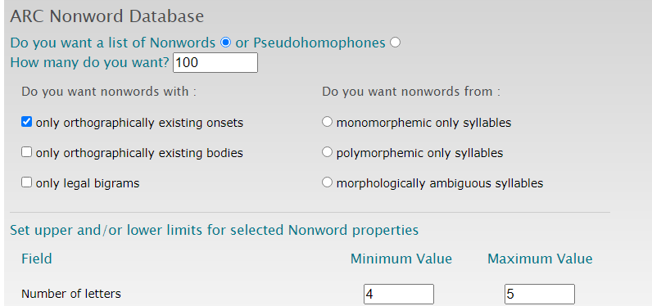

1. Scroll down to click **Send**
2. The output gives the nonwords, a pronunciation field, and the number of letters

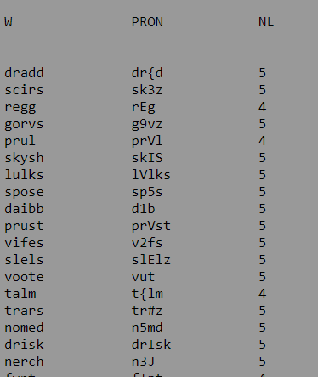

1. Select the nonwords that you want to use in your study and remember to make a note of the parameters that you set when creating the list, as the ARC database will generate a different set of stimuli each time (it’s random!)

## Appendix 1

Orthographic structure

An orthography is a set of conventions for writing a language and this includes spelling in accordance with accepted usage

Morphemes

A morpheme is the smallest linguistic part of a word that can have a meaning. In other words, it is the smallest meaningful part of a word. Examples of morphemes would be the parts "un-", "break", and "-able" in the word "unbreakable" thus a monomorphemic nonword could typically conform to a single syllabic structure, however in English an example of a monomorphemic word that has more than one syllable could be plastic as it cannot be broken down into a smaller meaningful unit